EXP-4

AIM:-
Implement Syntax Analyzer in C / Java / Python - Eg. LL(1)
- Generate the Predictive Parsing Table (take FIRST and FOLLOW as input for any grammar)
- Perform Parsing action for valid & invalid inputs based on the Parsing Table Generated.

THEORY:-
Predictive parsing is a parsing technique used in compiler design to analyze and validate the syntactic structure of a given input string based on a grammar. It predicts the production rules to apply without backtracking, making it efficient and deterministic.
Type of Predictive Parsing

1. Top-Down Parsing- It is a parsing strategy that starts at the top of the parse tree and works its way down by applying grammatical rules.
2. Bottom-up Parsing- It is a parsing strategy that starts with the lowest level of the parse tree and works its way up using grammatical rules.
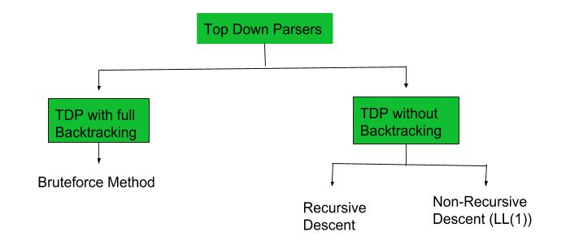
Predictive Parsers has the following components −
- Input Buffer− The input buffer includes the string to be parsed followed by an end marker $ to denote the end of the string.
- Stack − It contains a combination of grammar symbols with $ on the bottom of the stack. At the start of Parsing, the stack contains the start symbol of Grammar followed by $.
- Parsing Table − It is a two-dimensional array or Matrix M [A, a] where A is nonterminal and 'a' is a terminal symbol.
- Parsing Program − The parsing program performs some action by comparing the symbol on top of the stack and the current input symbol to be read on the input buffer.
- Actions − Parsing program takes various actions depending upon the symbol on the top of the stack and the current input symbol. Various Actions taken are given below

Predictive Parser Algorithm :
- Make a transition diagram(DFA/NFA) for every rule of grammar.
- Optimize the DFA by reducing the number of states, yielding the final transition diagram.
- Simulate the string on the transition diagram to parse a string.
- If the transition diagram reaches an accept state after the input is consumed, it is parsed.
LL(1) Parser-
LL(1) parsing is a top-down parsing method in the syntax analysis phase of compiler design. Required components for LL(1) parsing are input string, a stack, parsing table for given grammar, and parser. Here, we discuss a parser that determines that given string can be generated from a given grammar(or parsing table) or not.
Steps for constructing the SLR parsing table :
- Construct First sets for all symbols.
- Construct Follow sets for all non-terminals.
- Create a parsing table with non-terminals as rows and terminals + $ as columns.
- Fill table entries using First and Follow sets, handling ε (epsilon) productions.
- Resolve conflicts, ensuring each table entry contains at most one production.
- Implement a non-recursive predictive parsing algorithm using the parsing table.

SLR Parser -
SLR is simple LR. It is the smallest class of grammar having few states. SLR is very easy to construct and is similar to LR parsing. The difference between SLR parser and LR(0) parser is that in the LR(0) parsing table, there’s a chance of ‘shift reduce’ conflict. We can solve this problem by entering ‘reduce’ corresponding to the FOLLOW of LHS of production in the terminating state. This is called SLR(1) collection of items.

Steps for constructing the SLR parsing table :
- Writing augmented grammar
- LR(0) collection of items to be found
- Find FOLLOW of LHS of production
- Defining 2 functions:goto[list of terminals] and action[list of non-terminals] in the parsing table

Semantic Analysis-
Semantic Analysis is the third phase of Compiler. Semantic Analysis makes sure that declarations and statements of a program are semantically correct. It is a collection of procedures which is called by parser as and when required by grammar. Both the syntax tree of the previous phase and symbol table are used to check the consistency of the given code. Type checking is an important part of semantic analysis where the compiler makes sure that each operator has matching operands.

1. Semantic Analyzer:
It uses syntax tree and symbol table to check whether the given program is semantically consistent with language definition. It gathers type information and stores it in either syntax tree or symbol table.
2. Semantic Errors:
Errors recognized by semantic analyzer are as follows:
- Type mismatch
- Undeclared variables
- Reserved identifier misuse
3. Functions of Semantic Analysis:
- Type Checking –
Ensures that data types are used in a way consistent with their definition.
- Label Checking –
A program should contain label references.
- Flow Control Check –
Keeps a check that control structures are used in a proper manner.(example: no break statement outside a loop)
Syntax Directed Definition-
A CFG with attributes and rules is called a syntax-directed definition (SDD). The properties are linked to the grammar symbols in an extended CFG (i.e. nodes of the parse tree). The rules are associated with grammar production.
A grammar symbol's attribute can now be integers, types, table references, or a string.

For a non-terminal symbol (node) N, we can declare the value of a synthesized attribute:
- The attribute value of children.
- The total attribute values of N.
For a non-terminal symbol (node) N, we can declare the value of an inherited attribute:
- N's parent's attribute values.
- N's Siblings' attribute values.
- Total attribute values of N.

To determine the value of attributes at nodes in a parse tree, following steps need to be taken:
- Construct a parse tree.
- Then use SDD rules to assess the values of all the nodes in the parse tree's attributes.
- An annotated parse tree is formed via this improvised parse tree.

CODE:-
- Generate the Predictive Parsing Table
def removeLeftRecursion(rulesDiction):
store = {}
for lhs in rulesDiction:
alphaRules = []
betaRules = []
allrhs = rulesDiction[lhs]
for subrhs in allrhs:
if subrhs[0] == lhs:
alphaRules.append(subrhs[1:])
else:
betaRules.append(subrhs)
if len(alphaRules) != 0:
lhs_ = lhs + "'"
while (lhs_ in rulesDiction.keys()) \
or (lhs_ in store.keys()):
lhs_ += "'"
for b in range(0, len(betaRules)):
betaRules[b].append(lhs_)
rulesDiction[lhs] = betaRules
for a in range(0, len(alphaRules)):
alphaRules[a].append(lhs_)
alphaRules.append(['#'])
store[lhs_] = alphaRules
for left in store:
rulesDiction[left] = store[left]
return rulesDiction
def LeftFactoring(rulesDiction):
newDict = {}
for lhs in rulesDiction:
allrhs = rulesDiction[lhs]
temp = dict()
for subrhs in allrhs:
if subrhs[0] not in list(temp.keys()):
temp[subrhs[0]] = [subrhs]
else:
temp[subrhs[0]].append(subrhs)
new_rule = []
tempo_dict = {}
for term_key in temp:
allStartingWithTermKey = temp[term_key]
if len(allStartingWithTermKey) > 1:
lhs_ = lhs + "'"
while (lhs_ in rulesDiction.keys()) \
or (lhs_ in tempo_dict.keys()):
lhs_ += "'"
new_rule.append([term_key, lhs_])
ex_rules = []
for g in temp[term_key]:
ex_rules.append(g[1:])
tempo_dict[lhs_] = ex_rules
else:
new_rule.append(allStartingWithTermKey[0])
newDict[lhs] = new_rule
for key in tempo_dict:
newDict[key] = tempo_dict[key]
return newDict
def first(rule):
global rules, nonterm_userdef, \
term_userdef, diction, firsts
if len(rule) != 0 and (rule is not None):
if rule[0] in term_userdef:
return rule[0]
elif rule[0] == '#':
return '#'
if len(rule) != 0:
if rule[0] in list(diction.keys()):
fres = []
rhs_rules = diction[rule[0]]
for itr in rhs_rules:
indivRes = first(itr)
if type(indivRes) is list:
for i in indivRes:
else:
fres.append(indivRes)
if '#' not in fres:
return fres
else:
newList = []
fres.remove('#')
if len(rule) > 1:
ansNew = first(rule[1:])
if ansNew != None:
if type(ansNew) is list:
newList = fres + ansNew
else:
newList = fres + [ansNew]
else:
newList = fres
return newList
fres.append('#')
return fres
def follow(nt):
global start_symbol, rules, nonterm_userdef, \
term_userdef, diction, firsts, follows
solset = set()
if nt == start_symbol:
solset.add('$')
for curNT in diction:
rhs = diction[curNT]
for subrule in rhs:
if nt in subrule:
while nt in subrule:
index_nt = subrule.index(nt)
subrule = subrule[index_nt + 1:]
if len(subrule) != 0:
res = first(subrule)
if '#' in res:
newList = []
res.remove('#')
ansNew = follow(curNT)
if ansNew != None:
if type(ansNew) is list:
newList = res + ansNew
else:
newList = res + [ansNew]
else:
newList = res
res = newList
else:
if nt != curNT:
res = follow(curNT)
if res is not None:
if type(res) is list:
for g in res:
solset.add(g)
else:
solset.add(res)
return list(solset)
def computeAllFirsts():
global rules, nonterm_userdef, \
term_userdef, diction, firsts
for rule in rules:
k = rule.split("->")
k[0] = k[0].strip()
k[1] = k[1].strip()
rhs = k[1]
multirhs = rhs.split('|')
for i in range(len(multirhs)):
multirhs[i] = multirhs[i].strip()
multirhs[i] = multirhs[i].split()
diction[k[0]] = multirhs
print(f"\nRules: \n")
for y in diction:
print(f"{y}->{diction[y]}")
print(f"\nAfter elimination of left recursion:\n")
diction = removeLeftRecursion(diction)
for y in diction:
print(f"{y}->{diction[y]}")
print("\nAfter left factoring:\n")
diction = LeftFactoring(diction)
for y in diction:
print(f"{y}->{diction[y]}")
for y in list(diction.keys()):
t = set()
for sub in diction.get(y):
res = first(sub)
if res != None:
if type(res) is list:
for u in res:
t.add(u)
else:
t.add(res)
firsts[y] = t
print("\nCalculated firsts: ")
key_list = list(firsts.keys())
index = 0
for gg in firsts:
print(f"first({key_list[index]}) "
f"=> {firsts.get(gg)}")
index += 1
def computeAllFollows():
global start_symbol, rules, nonterm_userdef,\
term_userdef, diction, firsts, follows
for NT in diction:
solset = set()
sol = follow(NT)
if sol is not None:
for g in sol:
solset.add(g)
follows[NT] = solset

print("\nCalculated follows: ")
key_list = list(follows.keys())
index = 0
for gg in follows:
print(f"follow({key_list[index]})"
f" => {follows[gg]}")
index += 1
def createParseTable():
import copy
global diction, firsts, follows, term_userdef
print("\nFirsts and Follow Result table\n")
mx_len_first = 0
mx_len_fol = 0
for u in diction:
k1 = len(str(firsts[u]))
k2 = len(str(follows[u]))
if k1 > mx_len_first:
mx_len_first = k1
if k2 > mx_len_fol:
mx_len_fol = k2
print(f"{{:<{10}}} "
f"{{:<{mx_len_first + 5}}} "
f"{{:<{mx_len_fol + 5}}}"
.format("Non-T", "FIRST", "FOLLOW"))
for u in diction:
print(f"{{:<{10}}} "
f"{{:<{mx_len_first + 5}}} "
f"{{:<{mx_len_fol + 5}}}"
.format(u, str(firsts[u]), str(follows[u])))
ntlist = list(diction.keys())
terminals = copy.deepcopy(term_userdef)
terminals.append('$')
mat = []
for x in diction:
row = []
for y in terminals:
row.append('')
mat.append(row)
grammar_is_LL = True
for lhs in diction:
rhs = diction[lhs]
for y in rhs:
res = first(y)
if '#' in res:
if type(res) == str:
firstFollow = []
fol_op = follows[lhs]
if fol_op is str:
firstFollow.append(fol_op)
else:
for u in fol_op:
firstFollow.append(u)
res = firstFollow
else:
res.remove('#')
res = list(res) +\
list(follows[lhs])
ttemp = []
if type(res) is str:
ttemp.append(res)
res = copy.deepcopy(ttemp)
for c in res:
xnt = ntlist.index(lhs)
yt = terminals.index(c)
if mat[xnt][yt] == '':
mat[xnt][yt] = mat[xnt][yt] \
+ f"{lhs}->{' '.join(y)}"
else:
if f"{lhs}->{y}" in mat[xnt][yt]:
continue
else:
grammar_is_LL = False
mat[xnt][yt] = mat[xnt][yt] \
+ f",{lhs}->{' '.join(y)}"
print("\nGenerated parsing table:\n")
frmt = "{:>12}" * len(terminals)
print(frmt.format(*terminals))
j = 0
for y in mat:
frmt1 = "{:>12}" * len(y)
print(f"{ntlist[j]} {frmt1.format(*y)}")
j += 1
return (mat, grammar_is_LL, terminals)
rules=["S -> A a +",
"A -> A b | a B | c C",
"C -> c",
"B -> b B C | d"]
nonterm_userdef=['A','B','C']
term_userdef=['d','a','c','b','+']
sample_input_string="a r k O"
diction = {}
firsts = {}
follows = {}
computeAllFirsts()
start_symbol = list(diction.keys())[0]
computeAllFollows()
(parsing_table, result, tabTerm) = createParseTable()
OUTPUT:- (Generate the Predictive Parsing Table):
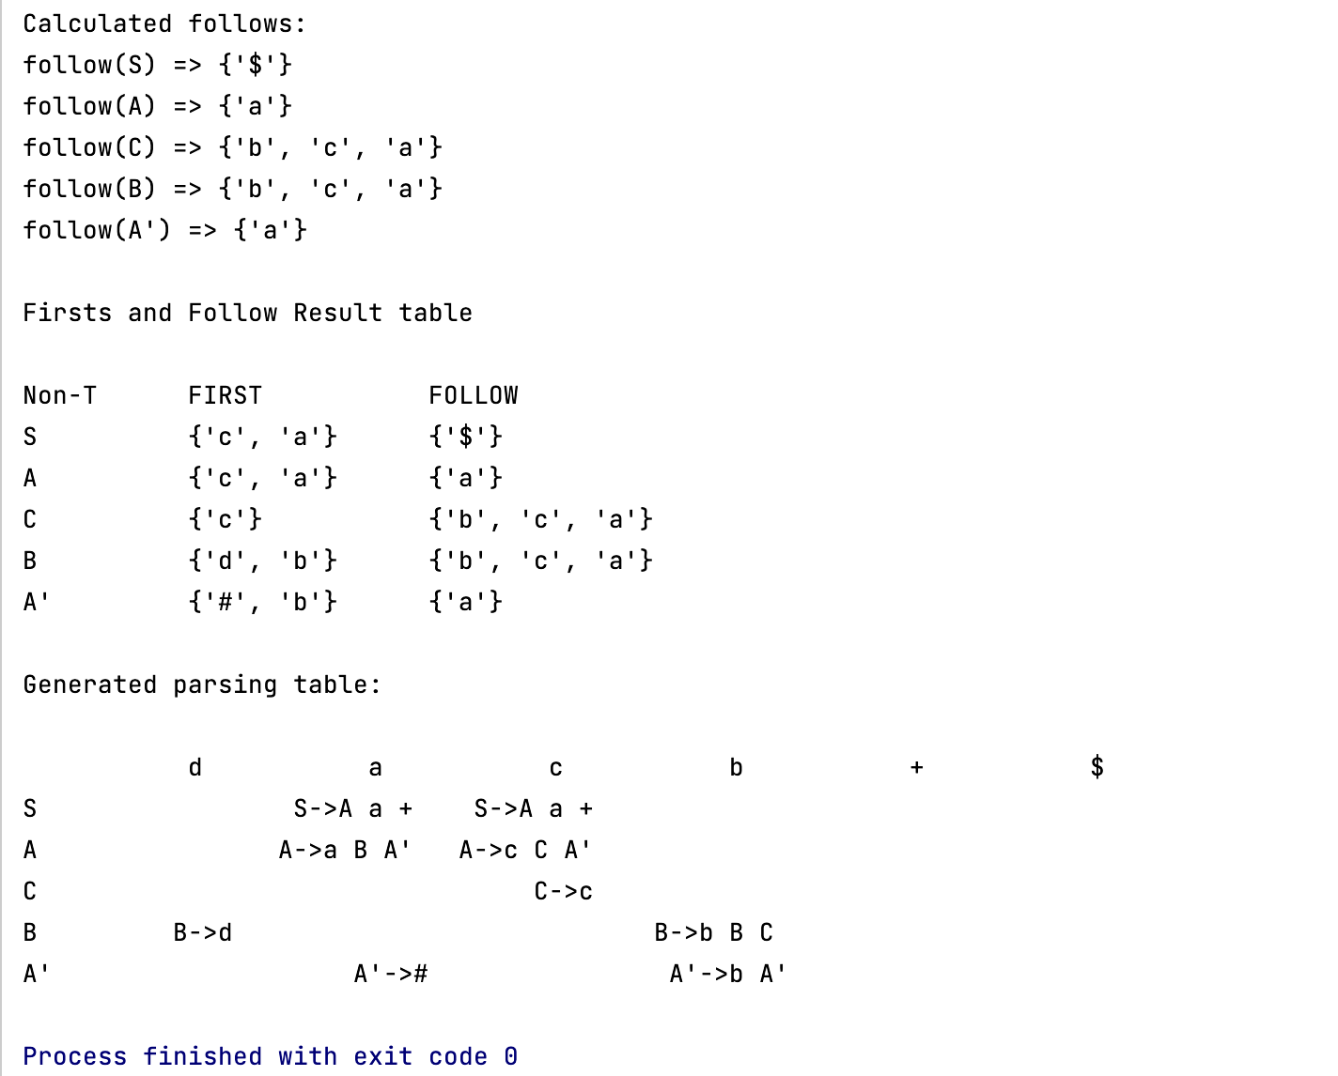
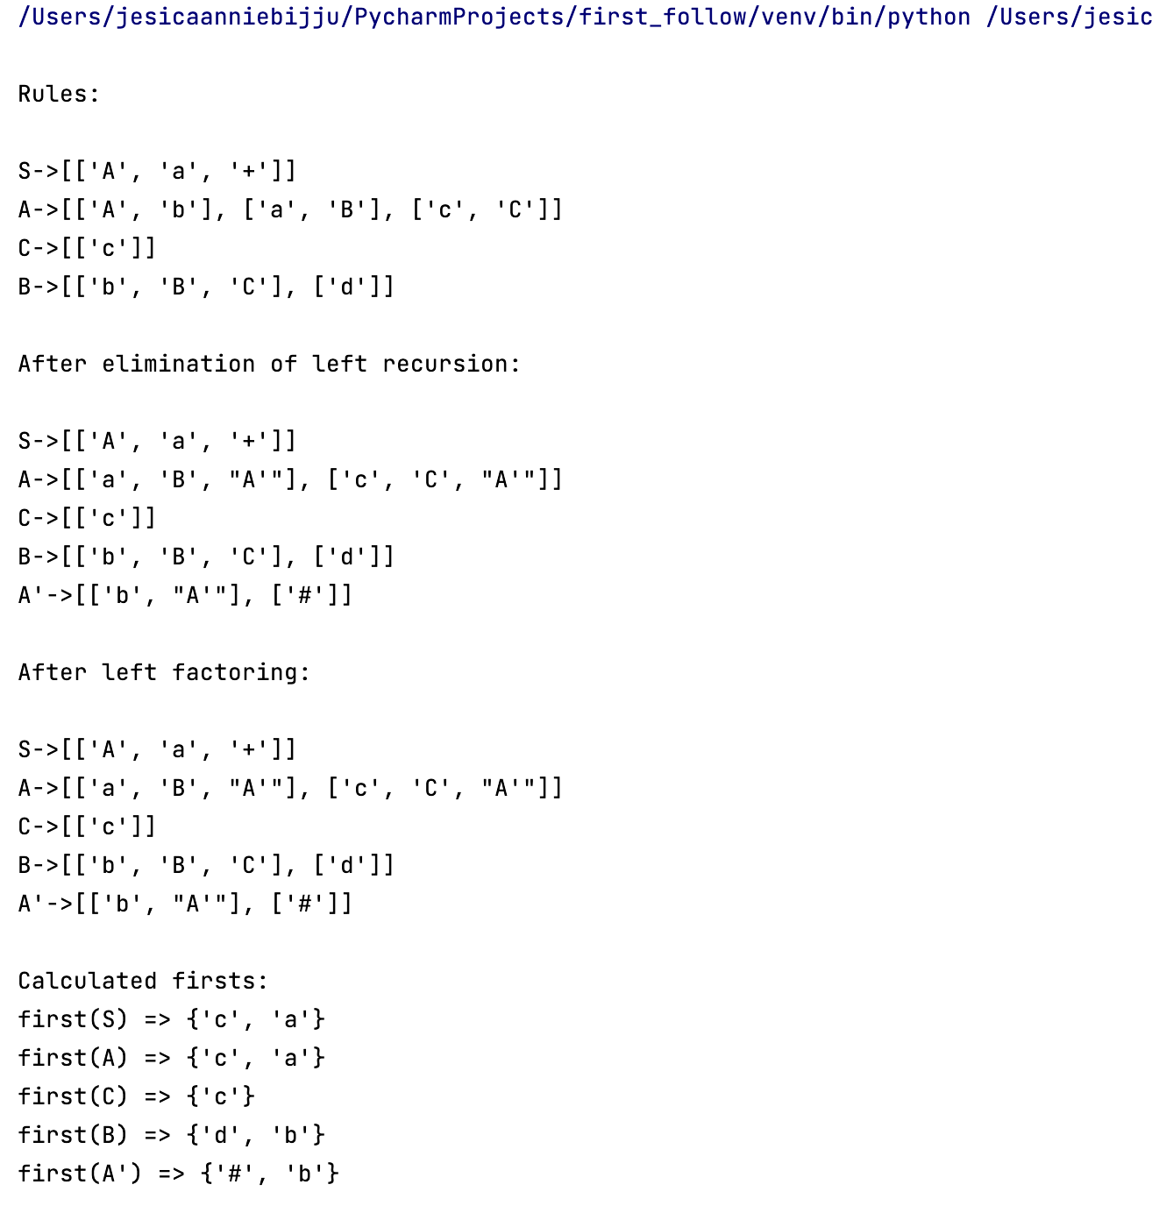

CODE:-
- Perform

2. Parsing action for valid/invalid inputs based on the Parsing Table Generated:
def validateStringUsingStackBuffer(parsing_table, grammarll1,
table_term_list, input_string,
term_userdef, start_symbol):

print(f"\nValidate String => {input_string}\n")
if not grammarll1:
return f"\nInput String = " \
f"\"{input_string}\"\n" \
f"Grammar is not LL(1)"
stack = [start_symbol, '$']
buffer = ['$'] + input_string.split()
buffer.reverse()
print("{:>20} {:>20} {:>20}".
format("Buffer", "Stack", "Action"))
while True:
if stack == ['$'] and buffer == ['$']:
print("{:>20} {:>20} {:>20}"
.format(' '.join(buffer),
' '.join(stack),
"Valid"))
return "\nValid String!"
elif stack[0] not in term_userdef:
x = nonterm_userdef.index(stack[0])
y = table_term_list.index(buffer[-1])

if x < len(parsing_table) and y < len(parsing_table[x]):
entry = parsing_table[x][y]
if entry != '':
print("{:>20} {:>20} {:>25}".
format(' '.join(buffer),
' '.join(stack),
f"T[{stack[0]}][{buffer[-1]}] = {entry}"))

lhs_rhs = entry.split("->")
lhs_rhs[1] = lhs_rhs[1].replace('#', '').strip()
entry_rhs = lhs_rhs[1].split()
stack = entry_rhs + stack[1:]
else:
return f"\nInvalid String! No rule at " \
f"Table[{stack[0]}][{buffer[-1]}]."
else:
return f"\nInvalid String! Index out of range for " \
f"Table[{stack[0]}][{buffer[-1]}]."

else:
if stack[0] == buffer[-1]:
print("{:>20} {:>20} {:>20}"
.format(' '.join(buffer),
' '.join(stack),
f"Matched:{stack[0]}"))
buffer = buffer[:-1]
stack = stack[1:]
else:
return "\nInvalid String! " \
"Unmatched terminal symbols"
your_generated_parsing_table = [
['', '', '', 'S->A k O', '', '', '', ''],
['', '', '', 'A->a A\'\'', '', '', '', ''],
['', '', '', '', 'A\'\'->C A\'', 'A\'\'->B A\'', 'A\'\'->B A\'', ''],
['', '', '', '', 'C->c', '', '', ''],
['', '', '', '', '', 'B->b B C', 'B->r', ''],
['A\'->#', '', 'A\'->d A\'', '', '', '', '', ''],
]
print("\nLL(1) Parsing Table:")
for row in your_generated_parsing_table:
print(' '.join(row))
# Example LL(1) parsing table, grammar information, and other components
parsing_table = your_generated_parsing_table
grammarll1 = True
table_term_list = ['k', 'O', 'd', 'a', 'c', 'b', 'r', '$']
term_userdef = ['k', 'O', 'd', 'a', 'c', 'b', 'r', '$']
nonterm_userdef = ['S', 'A', 'A\'', 'C', 'B','A\'']
start_symbol = 'S'
input_string = "a r k O"
# Validate the input string
validity = validateStringUsingStackBuffer(parsing_table, grammarll1,
table_term_list, input_string,
term_userdef, start_symbol)
print(validity)

OUTPUT:-

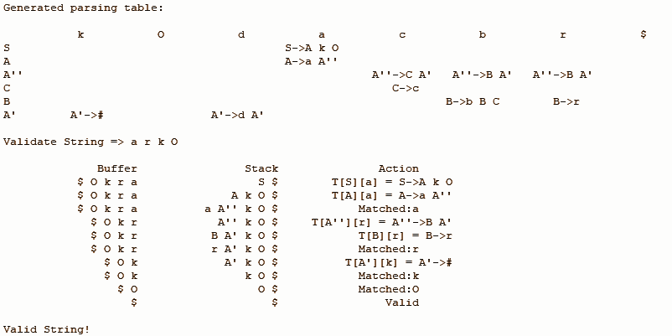

CONCLUSION:-
Operator Precedence Parsing, a type of Shift-Reduce Parsing, uses operator grammar and an input string to generate a parse tree based on symbol priorities. SLR Parser (Simple LR) addresses shift-reduce conflicts in grammar, constructed through specific steps. Semantic Analysis ensures program correctness using the syntax tree and symbol table. It involves tasks like type checking and detecting semantic errors. Syntax-Directed Definition (SDD) is a CFG with attributes and rules, associating properties with grammar symbols that construct annotated parse trees . Synthesized attributes depend on children or total attribute values, while inherited attributes depend on parent or sibling attribute values.

